Judges Biographies

Professor Arpan Guha, Deputy Medical Director, Royal Liverpool & Broadgreen University Hospitals NHS Trust

Professor Arpan Guha is Deputy Medical Director at the Royal Liverpool & Broadgreen University Hospitals NHS Trust, where he has a remit for safety learning and processes. He is also the theme lead for patient safety for the University of Liverpool’s medicine curriculum, which he devised and developed. He is Johns Hopkins, USA, trained in the science of patient safety and was one of the pioneers of establishing human factors in healthcare in the Northwest of England, over a decade ago. He has published widely on healthcare team and leadership in healthcare and his practical interest in developing innovative solutions to healthcare safety problems led to using a hackathon method for safety.

Mark Duman, Director, MD Healthcare Consultants

Mark is a rare blend of clinician, management consultant and
patient advocate. He works with organisations to help them realise
the full benefit of their services and products, especially through
the often untapped potential of patients and the public.
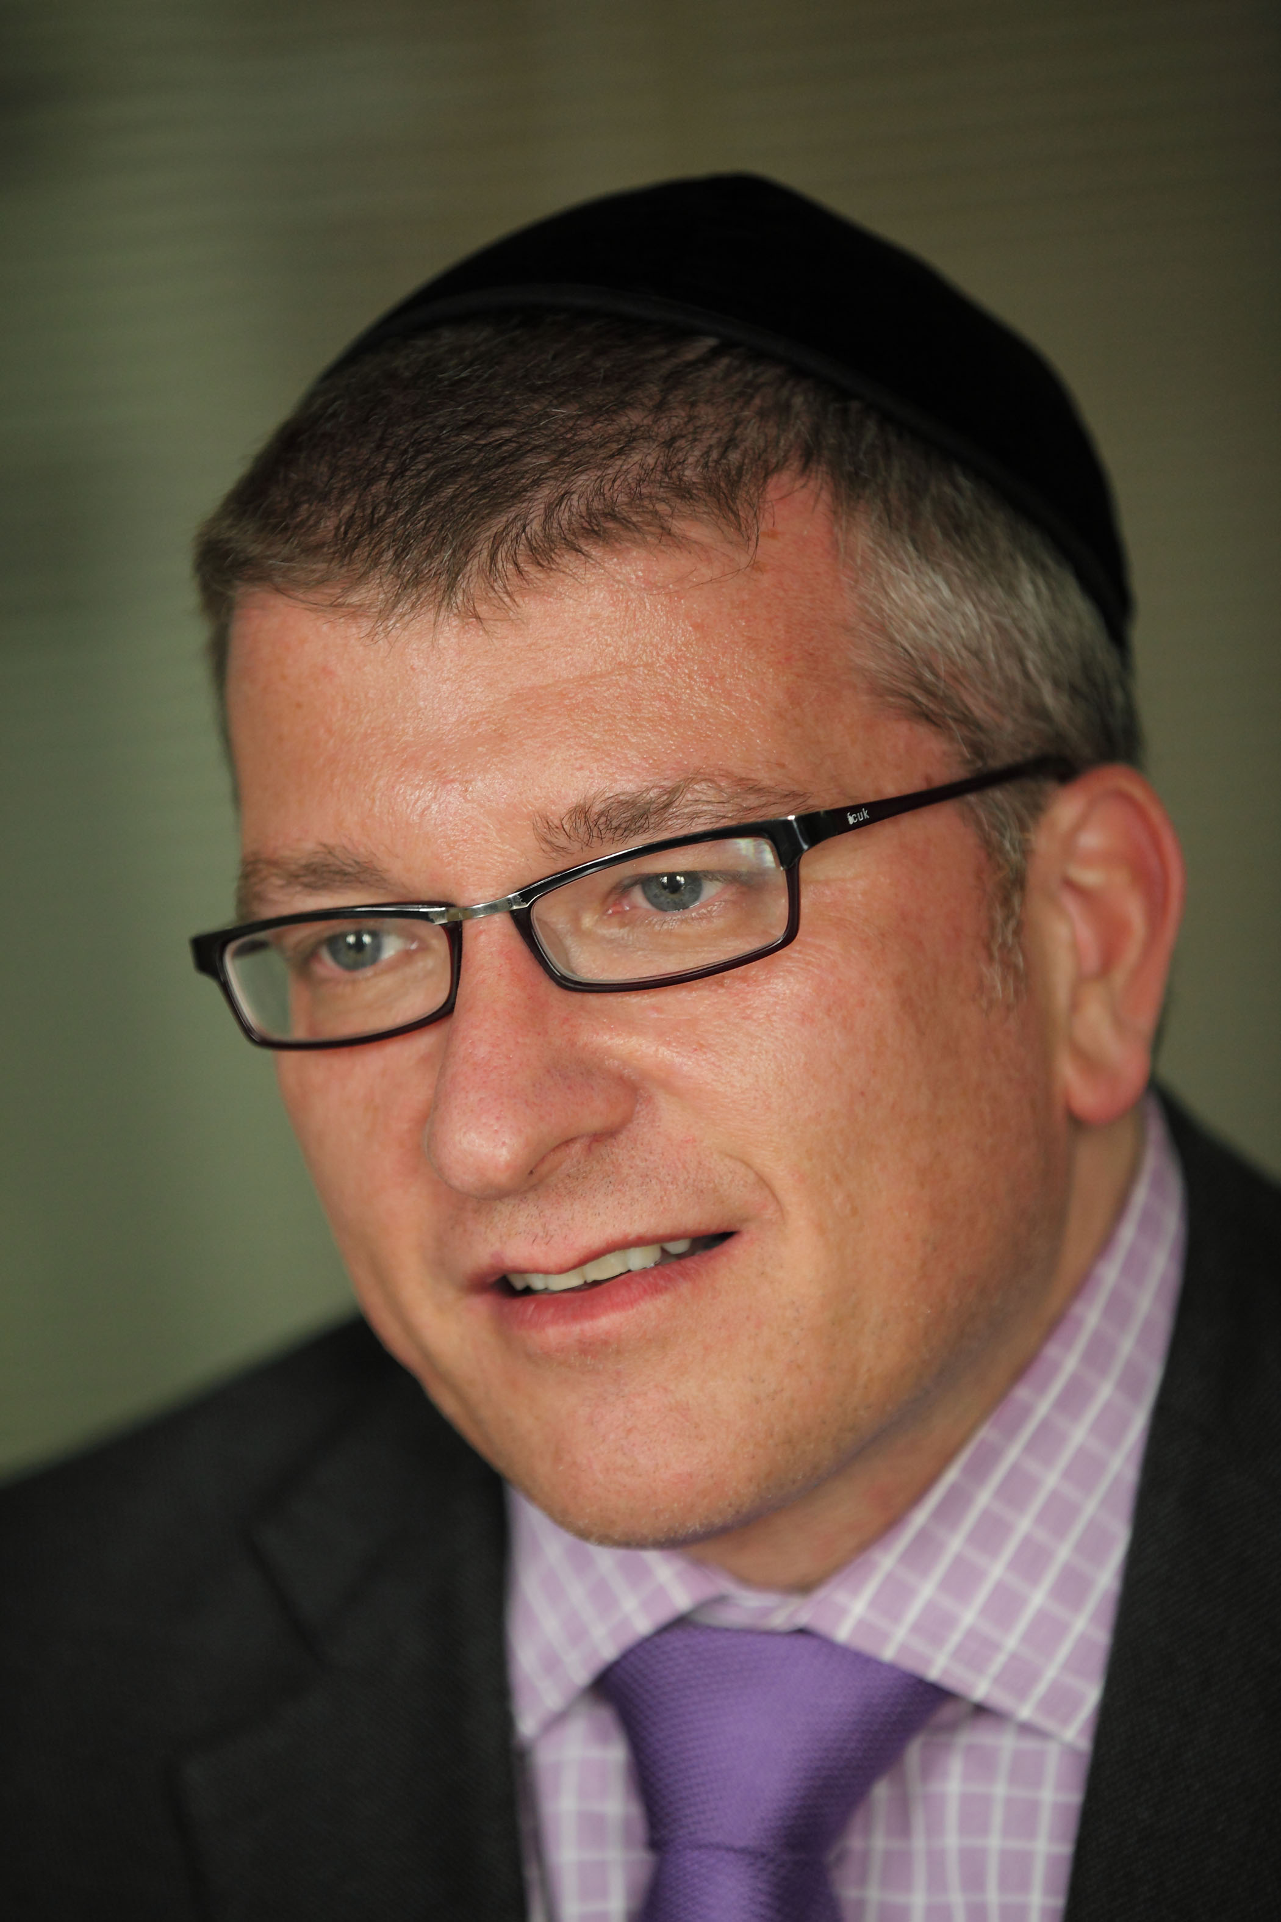
At The King’s Fund, Mark promoted shared decision making, founded the Ask About Medicines campaign & authored ‘Producing Patient Information’. In the BBC he developed a range of behavioural change interventions to improve people’s health and lifestyle.
Following roles in publishing and telecoms, Mark moved into consulting with clients including Cancer Research UK, Care Quality Commission, Pfizer, NHS England and Microsoft.
In addition to various advisory and mentor roles, he is a Non-Executive Director of the Patient Information Forum, a Director at Intelesant working on Smarter Homes, Health & Care and an Honorary Lecturer at the University of Salford.
Mark is a NW Service Champion for Diabetes UK who lives happily married in Salford, England (despite being Scottish).
@MarkDuman
http://uk.linkedin.com/in/mduman

Jan Vaughan, Associate Director, North West Coast Strategic Clinical Network

Jan started her career as an Accountant in industry and joined the NHS in 1993, since then she has held senior positions in Finance and General Management in primary and secondary care as well as SHA level. In addition she has sat on a number of national working groups and has presented her work both nationally and internationally.
Jan has spent since 2002 working within the network environment firstly in Cardiac and Stroke. Jan was appointed Director of Clinical Networks in April 2011 the role encompassed Cancer, Cardiac, Stroke, Neurosciences, Kidney Care, Critical Care and Neo-natal care Networks. Subsequently she was appointed as Associate Director for Strategic Clinical Networks and Senates for Cheshire and Merseyside in 2012 and her remit extended to include, Lancashire and South Cumbria in April 16. Jan has an MSc from Manchester Business School. She is currently undertaking her Doctorate.

Matthew Parkes, Sepsis Survivor and Volunteer at the UK Sepsis Trust

Matthew has been married for nearly seven years to Pamela, who is the director of a law firm. He has a five year old daughter and two stepchildren, who are 12 & 13. Matthew used to work as a Corporate Account Manager in the telecoms and IT sector.

Matthew and his family go to Majorca about 4 times a year and in August of 2015 he went there with his wife and daughter, Sophia, to celebrate their fifth wedding anniversary and to take Sophia to see the hotel where they had their honeymoon, five years previously.

Matthew and his wife caught throat infections which got progressively worse. Pamela got rid of hers, but Matthew deteriorated. He collapsed in the apartment on the 6th day and was taken to hospital, where he was told that he had life threatening pneumonia and therefore they were inducing a coma or "you will be dead within the hour". That was the last thing Matthew remembers.

Matthew then developed sepsis from the pneumonia infection, which led to an array or multi organ failures and cardiac arrests. After being in a coma for 4 months or so, he was then woken from the coma back in England, only for Pamela to tell him that he was going to lose both of his legs and most of his left hand.

Since then, it has been a huge struggle and has had a huge impact on Matt and his family's lives. Matthew has got better day by day and has had to learn to walk all over again.

He now never says, "I can't do that", he just does it, or at least tries.

Matthew is now a representative for the UK Sepsis Trust and has spoken in The House of Commons for World Sepsis day, on the riverbank, to a crowd of over 60 people and introduced the Manchester premiere of the Film 'Starfish.

He continues to work for the trust and is also doing an 11,000ft parachute jump, to raise for money for the trust. He have also done numerous television and newspaper interviews to try and raise awareness of sepsis.

Matthew is doing all of this because there is not enough awareness of Sepsis and my own doctor didn't even know about Post Sepsis Disorder, which his wife and himself had to self-diagnose.

Sepsis kills around 44,000 people every year and Matthew wants to significantly reduce this figure in the next year and going forward.

Hazel Richards, Director of Nursing, NHS England
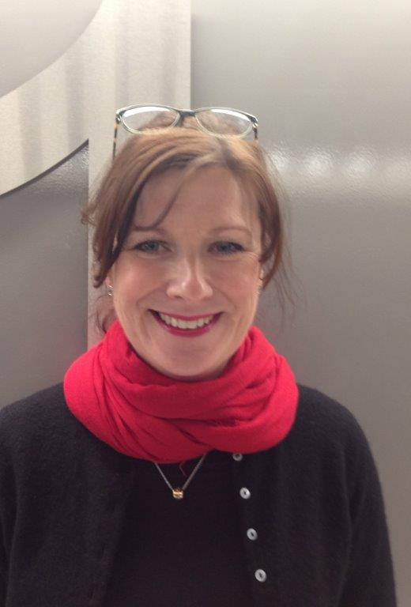
Hazel Richards is the Director of Nursing for Cheshire & Merseyside. Before taking up this role in April 2016, Hazel worked as the Regional Deputy Chief Nurse for the North. Prior to this she has held several Executive Director of Nursing posts in acute, mental health and community Trusts. Hazel has a strong track record of improving services for patients and staff and has a passion for patient and family centred care. She was awarded the Florence Nightingale Leadership Scholarship for this work.

